**RS**

RICE SHOWER

***Thieves Racer***

***GAME DESIGN DOCUMENT***

**SUMMARY**

1. **Design History**
2. **Vision Statement**
   1. Game logline
   2. Gameplay Synopsis
3. **Audience, Platform, and Marketing**
   1. Target Audience
   2. Platform
   3. System requirements
   4. Top performers
   5. Feature comparison
4. **Legal Analysis**
5. **Gameplay**
   1. Overview
   2. Gameplay description
   3. Controls
      1. Interfaces
      2. Rules
      3. Scoring/winning conditions
   4. Modes and other features
   5. Levels
   6. Flowchart
6. **Game Characters**
   1. Characters design
   2. Types
      1. PCs
      2. NPCs
7. **Story**
   1. Synopsis
   2. Complete story
   3. Backstory
   4. Narrative devices
   5. Subplots
8. **The Game World**
9. **Media List**

**Team members**

|  |  |
| --- | --- |
|  | **Lin Liya**  AI  Game Design  UI Design  [liya.lin@studenti.unimi.it](mailto:liya.lin@studenti.unimi.it) |
|  | **Aragon McAyrton**  AI  Game Design  Gameplay programmer  [mcayrton.aragon@studenti.unimi.it](mailto:mcayrton.aragon@studenti.unimi.it) |
|  | **Chen Xiao Oscar**  AI  Game Design  Programming  [xiaooscar.chen@studenti.unimi.it](mailto:xiaooscar.chen@studenti.unimi.it) |

**1. DESIGN HISTORY**

* 4/5 added cover and design history
* 6/5 added chapter 3

**2. Vision Statement**

Thieves Racer is a 3D RPG adventure game for single or co-op multiplayer in which the player controls a character inside the magical world of Teyria, which consists of 7 islands to explore and complete by defeating every levels in order to proceed on the next map, all the way to the final island where the player will face and defeat the final boss. The character will gain experience and power-ups in order to survive and defeat more and more difficult levels. The enemies are mostly pirates that have invaded and conquered each island. The player will have to explore each island, talk to various characters he met and obtain better equipments to defeat the pirates. Other players can join the game via online co-op so they can help each others and share experiences and rewards.

**2.1 Game logline**

Race through the 7 seas.

**2.2 Gameplay Synopsis**

**3. Audience, Platform, and Marketing**

Developing a good game today can require a lot of time and resources, especialy online games, where the developers have to work constantly to bring new updates the game with new contents, managing feedbacks and fix a lot of bugs. What we do is to create a simple online game that will run on smartphones and maybe later also on desktops and consoles.

**3.1. Target Audience**

The game we created is meant to be mantained for as long as possible in order keep the players playing at the game. We plan on releasing constantly new contents to the game without changing the entire game structure. Every game has its own target audience that depend on the type of gamer and platforms that on which the game will run. This game in particular is addressed to the young mobile gamers with a lot of free time and a little financial independence, but of course the ideal target could be anyone.

There are various type of players that can be divided by different parameters like age, geographical location and player types for example.

**AGE**

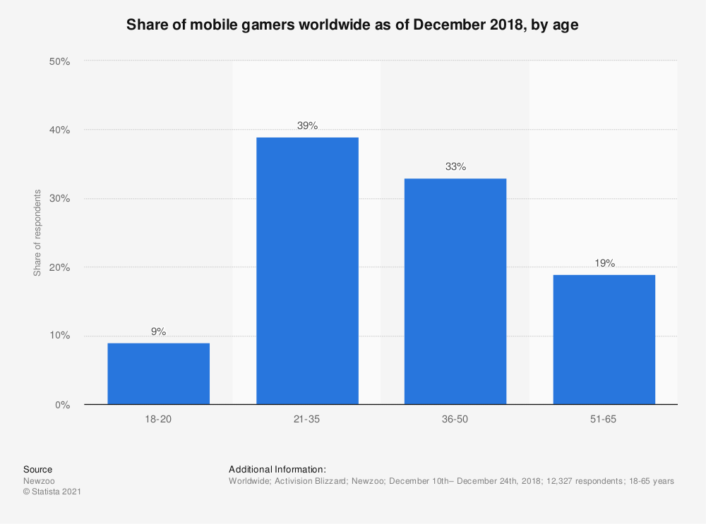

It’s not a surprise that many mobile gamers come from the young generations since they have access to the latest tecnology and a lot of free time to spend in playing games, but of course they also expect a lot of quality from the content and a good service in general. They also spend a lot of time with friends to play games together through online co-op sessions or streaming their own gameplay. They are probably the most influencial elements of the game because they are themselves the ones that keep the game’s reputation alive.

**GEOGRAPHICAL LOCATION**

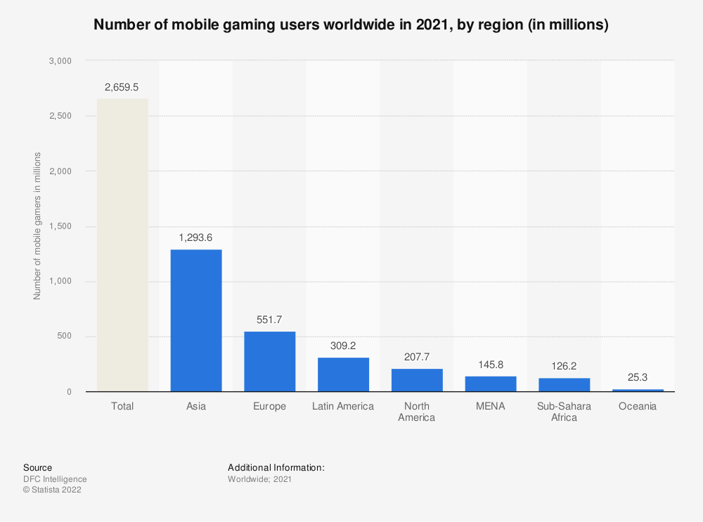

This also is to be expected since half of the world’s population is concentrated in Asia and many big gaming companies are located in those area. The gaming market over there is quite competitive and we’re not expecting to become big anytime soon. We’ll release our game globally anyway and update the game with new contents and features. Only time will tell us which direction we should be moving forward.

In order to keep the game alive for as long as possible, is also essential to build a community base and carefully observe how the players are experiencing the game. It’s important to keep communicating with the players through social networks such as Discord, Youtube, Reddit, Twitter… Many gamers today also come to check out a new

game from reviews by online influencers. They are like web stars that often collaborate directly with the game company…

**3.2. Platform**

**IMPORTANCE OF GOOD HARDWARE**

First impressions are important to attract new players to the game. This usually depends on the artworks of the game such as graphics, soundtracks and storyline, but in order to experience better these kind of elements, it’s important that the game is running possibly on a good performing hardware. There are different kind of platforms on which the game can be played but they are all updating their component at a fast rate, almost every year, especially mobile smartphones, tablets and even desktop computers.

The PC platform is still the most preferred platform today, especially in the recent years there is a growth in the home entertainment and many people have grown a interest in building their own desktop set up for both gaming and working purposes, but we still believe that *the only legitimate use of a computer is to play games*. Today’s smartphones are performant enough to be even be compared to PCs but they don’t need any set up and can run decent games that can be played at any moment.

**3.3. System requirements**

The game will run on mobile smartphone with possibly the latest versions of iOS and Android. An internet connection will be required to play the game.

**3.4. Top performers**

**Azur Lane**

|  |
| --- |
|   **Developer:** Manjuu, Yongshi  **Publisher:** Yostar Limited, X.D. Global, Bilibili, Yostar  **Platform:** Android, iOS  **Initial release date:** May 25, 2017 |

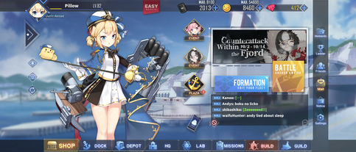Azur Lane is a side-scrolling shoot 'em up, simulation and role-playing video game. Players collect characters that are moe anthropomorphic interpretations of World War II warships ("shipgirls"), mainly from the United States Navy, Royal Navy, Imperial Japanese Navy and Kriegsmarine, with other ships from the French Navy (both Vichy and Free France flavors), Republic of China Navy, People's Liberation Army Navy, Regia Marina, Soviet Navy, Imperial Russian Navy, and Imperial German Navy being added later. Players organize them into fleets of six and confront AI-controlled enemies or other players' fleets. These ships can gain experience points (EXP) from various

methods (such as from battles, completing commissions, or placing these ships into Dormitories), and they require a certain amount of EXP to gain a stronger level. They have a certain maximum level limit on how far players can level up their ships, which can be increased via Limit Break. Most characters have their own set of upgradable abilities that can be activated in battle.

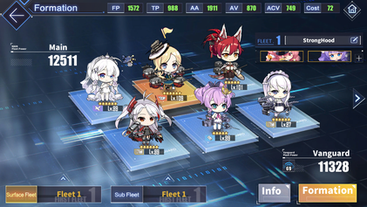When preparing for the game's main mode, players can organize two fleets (as the game progresses, they will unlock up to a maximum of 6 fleets) consisting of a front row and a back row, with three slots available in each row. Destroyers, light cruisers, and heavy cruisers can be allotted to the front row, while the back row is reserved for battleships, aircraft cruiser, monitors, repair ships, battlecruisers and aircraft carriers.

Different combinations of ships are required to achieve victory in different battle situations. Players may then select and enter a map.

On entering a map, the player's fleet is placed on a grid-like map similar to that in the game Battleship. The map contains nodes, which are either combat nodes which are enemy fleets, some immobile and others that pursue the player, or non-combat nodes which provides ammunition or mystery nodes which can provide supplies such as repair kits, upgrade materials or can spawn a special combat node called a Treasure Fleet. Players must navigate optimally and assemble their fleets tactically, to clear obstructing enemies and, using minimal movements, reach the map's boss. When the player moves their fleet across the map, they can be ambushed in random encounters from which they may take damage, or they can be forced to engage the enemy, using fuel and ammo. Fuel is one of the two in-game resources. Ammo points are assigned to player fleets at each map, with one ammo point deducted at each battle. Fleets that run out of ammo can still fight but may only deal half damage.

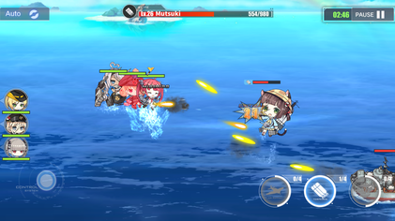**Battle interface of Azur Lane**

When battling an enemy, players can use a virtual joystick to control the front row, which can automatically fire shells at targets and manually launch torpedoes. While stationary, the back row can send shell barrages and the player can manually call in airstrikes. These will activate a bullet-clearing effect, removing all projectiles and torpedoes on screen. Players have an auto mode option to give up this control to the game's AI. Characters' health is fully replenished when completing or exiting a map. Morale points are deducted for each fleet character in a battle. Should a character fall in battle, they cannot join in further action on the map and a larger number of morale points are deducted for the fallen character at the end of the battle. Sustained low morale for a character decreases their stats and affection points. Low affection points lead the character to greet the player with vocals reflecting their disappointment.g

The game features a player versus player mode. The player may prepare a defence fleet and organize an offence fleet to challenge opposing players' defence fleets. In this mode, battles are controlled entirely by AI, and the bullet-clearing effect of airstrikes is disabled. Tokens can be gained and the player's ranking can rise through victory in this mode. Players receive no penalty if they lose a challenge or their defence fleet is defeated by other players. Exclusive characters and other items can be obtained using tokens (which is called Merits). The ranking is refreshed every 15 days.

**CUPHEAD**

|  |
| --- |
| **Shape  Description automatically generated with low confidenceDeveloper:** Studio MDHR  **Publisher:** Studio MDHR  **Platforms:** Nintendo Switch, PlayStation 4, Xbox One, Microsoft Windows, macOS  **Initial release date:** September 29, 2017 |

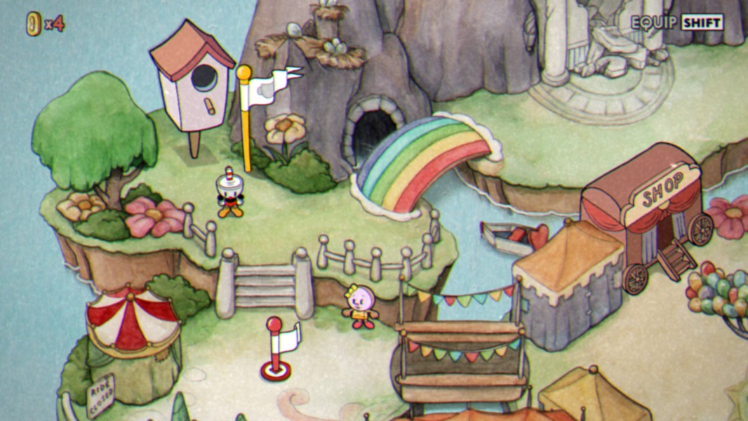Cuphead's gameplay is centered on continual boss fights, interspersed with run-and-gun levels. Each is housed in one of four worlds, with the final fight against the Devil. Each boss fight includes a simple, normal, and expert difficulty mode (with the exception of the final two bosses, which lack a simple mode). Defeating every boss on normal mode is required to complete the game, and expert mode is unlocked upon completion. Most boss battles take place on land, although some have the player piloting an aeroplane and play like a side-scrolling shoot 'em up. The game includes role-playing elements and a branching level sequence. Player characters have infinite lives, maintaining all equipment between deaths. Equippable weapons and special abilities known as Charms can be purchased from Porkrind's Emporium, an in-game shop, using coins found in levels and the overworld. Player characters can use a slapping parry attack on objects marked in pink to various effects, the most important of them being increasing a super meter that enables more powerful attacks. The super meter is represented by a row of five playing cards, all of which must be filled to use one of the three strongest attacks ("Super Arts") in the player's inventory. A less powerful strike can be executed at the cost of one card, its particular form determined by the currently equipped weapon. The Super Arts are earned by entering three mausoleums, one in each of the first three worlds, and parrying a group of invading ghosts to stop them from reaching an urn at the center of the screen.

After completing a level, the player is ranked with a grade based on performance, based on factors such as the time taken to complete the level, damage avoided, and number of parried attacks. The levels are accessible through a top-down perspective overworld with its own secret areas. The game has a two-player local cooperative mode, in which either player character can return to the game after being killed if the other one parries his soul before it rises off the screen. Cuphead's brother, Mugman, acts as an alternative skin and potential co-op partner within the game.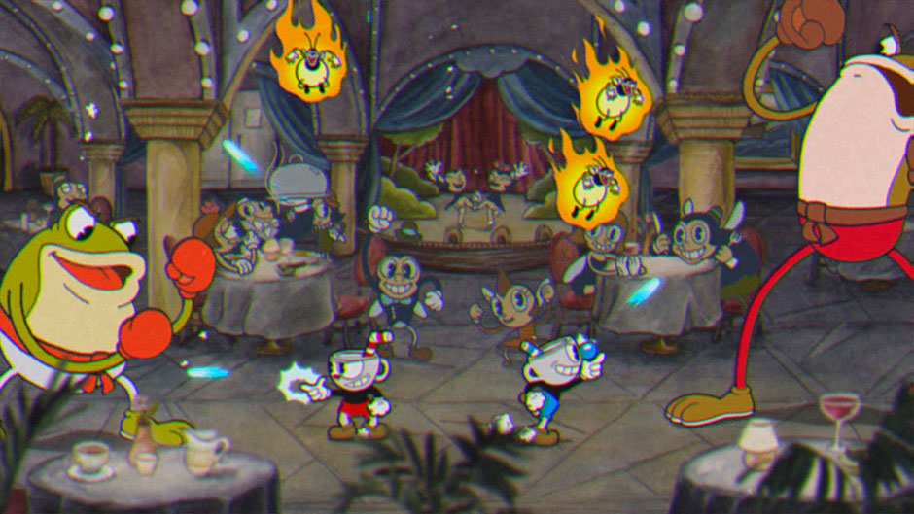

**GALAGA: WARS**

|  |
| --- |
|   **Developer:** Paladin Studios  **Publisher:** Bandai Namco  **Platform:** iOS, Android  **Initial Release:** June 10, 2016 |

Galaga: Wars is a take on the classic 1981 arcade game Galaga for mobile devices. It consists of several levels called sectors where waves of enemies need to be defeated in a vertically scrolling environments. The space ship fires automatically and it can be moved around anywhere on the screen by tapping, holding and dragging it. As soon as the player releases the finger the game is paused.

Initially only the Fighter ship from Galaga is available. The game is free-to-play, but additional ships can be bought through an in-app purchase. There is FX-01 from Starblade, Galaxip from Galaxian and Solvalou from Xevious. Defeated enemies leave behind power-ups that are unique for each ship, except for the one that briefly provides a faster firing rate. The Figher ship for instance has access to a coin magnet, a jumbo shot, a missile barrage and a turret, while FX-01 can briefly become invulnerable through a ghost form, Galaxip has ricochet bullets and Solvalou has a ram shield to destroy enemies. Defeated opponents also leave behind coins that can be used to upgrade each power-up multiple times to enhance the effects. Sometimes a captured ship can be freed and then it briefly acts as a wingman, copying the main ship's movement and firing.

Sectors generally end with a boss or a wave very reminiscent of the original Galaga. The scrolling environment is changed into a fixed-screen one and a large wave of enemies appears near the top in rows as in the original game, with ships swooping down quickly. After completing sectors there is sometimes a bonus flying section where additional coins can be picked up, shown from a behind view. The ship only has one life, but an additional one can be earned by spending coins or watching a video advertisement. An in-app purchase can also provide a coin doubler. Enemy ships drop warp modules. Once a sector is completed, it can be accessed right away, skipping the earlier ones, by spending these modules.

|  |  |
| --- | --- |
|  |  |
|  |  |

**3.5. Feature comparison**

|  |  |  |  |  |
| --- | --- | --- | --- | --- |
| **Title** | **Thieves Racer** | **Azur lane** | **Cuphead** | **Galaga: Wars** |
| **Genre** | RPG | RPG | Platformer | Arcade |
| **Graphics** | 3D | 2D | 2D | 3D |
| **Platform** | Mobile | Mobile | PC/Console | Mobile |
| **Engine** | Unity | Unity | Unity | Unity (?) |
| **Offline mode** | Single player | No | Single player or co-op | Single player |
| **Online mode** | Co-op Multiplayer | Single player and PvP | No | No |
| **Story** | Yes | Yes | Yes | No |
| **Character upgrade** | Yes | Yes | Yes | Yes |
| **Interactable map** | Yes | Yes | Yes | No |
| **In-game shop** | Yes | Yes | Yes | Yes |
| **Multiplayer** | Yes | Yes | Yes | No |
| **Character control** | In-game joystick | In-game joystick | Keyboard/  Joystick | Touch Controls |
| **Require internet connection** | No | Yes | No | Yes |

**4. Legal analysis**

**5. Gameplay**

**5.1 Overview**

In a ancient land composed by 7 island where every island was protected by a goddess, an army of bad pirates appeared, people were subdued to the power of this army, once every island lose the battle, the darkness won and the won’t be peace anywhere. After they conquered the sixth island, the last goddess of the last island summoned a hero, the future of the land is in this person’s hand.

**5.2 Gameplay description**

There is 2 playable mode, offline and online.

Offline

Doesn’t require an internet connection to play and everything will be stored locally (not by playerprefs).

First time

If it is the first time the player log in, he will be asked to insert a name and after that automatically enter the tutorial.

Tutorial

The tutorial will introduce the story before the character arrived in Teyra land and will teach the player the basic commands to move the character.

Normal

If it’s not the first time, after the player staarts the offline mode, the player will be sent to the world of Teyra, where he can move the character and decide to do whatever he wants like fighting enemy or collecting money, spend money in a shop to buy new ships, upgrades or to interact with the NPCs. There will be a total of 7 islands available, every island with its own story, dialogues, equipments and enemies, and the player has to clear the story of the island, before moving to the next one.

Story and battle

To progress with the story, the player must fight the enemy, once the player is near to an interactable object such as the enemy, he can interact with it, it will show a description menu with the stars achieved and 2 options: start the battle or back. The battle scene consist **in ….. PARTE DI MC**

In some battle, there will be a dialogue that activates at start or when the boss is about to appear. It is used to start an event, for example a battle where we got ambushed, or it will give an advice or hidden tip for some strong enemies.

Dialogue

If a player is near a dialogue NPC such as goddess, the interact will be active and he can open a dialogue with the selected npc, there will be multiple choice in the dialogue which will lead to different answer from the npc, to discover every little thing, you need some more talk.

Reward and win

When the player wins, they will be rewarded with in-game currencies to be spent in the game shop.

Lost

If the player loses he can chose to restart the game or go back to the map.

Shop

The shop is an interactable building, when th player interact with the shop, it will appear a window and show the the available items.

Upgrade & inventory

When the player buys a new ship, this will automatically update to other system, such as upgrade and inventory system.

The upgrade system is a gameObject house which is the same as the shop, the difference is that it will show the stats of the ship and eventually give the player the possibility to upgrade it by spending money.

The inventory is a button, when clicked it will show the item bought from the shop and its current stats and give the functionality to switch to a different ship to be used in battle.

Currency

There are only 2 ways to obtain the game currency: defeating the enemies, since the level can be repeated and you will always get reward after clearing it; or you can directly fill the cash through in-app purchase to obtain the game currency.

Map

When the player beat all the enemies in the map at least once, he will unlock a new map, to move around the map we have a ship set up in the map which allow our player to travel around available maps. Once you are near the travel ship, it will automatically activate the interaction with player, and player can chose to switch map or stay in the current map.

Ending

The game is cleared when the player successfully beat the last enemy pirate and set free all islands in Teyra.

After this, there will be opened a challenge stage, which is a level where the enemy will appear endlessly with increasing difficulty.

Online

The online mode can be played both by single player or 2 players. Every function descripted above also work for online mode except for dialogue, map menu and enemy interaction.

Difference between online and offline mode

The purpose of this game is similar to the ones like Cuphead, you can play and enjoy the story alone, but you can also clear it and enjoy the story together with a friend, so the difference is:

-Dialogue system: if a player start a dialogue with a NPC, the other one start the same dialogue at the same time, if a player chose an option, the other one get the same chose and consequence.

-Switch map, if a player switched the map, both switch to the same map.

-Enemy interact, if a player opens the enemy menu, both open the same menu, if one press start battle, both player will be automatically sent to the scene to fight together.

After beat all enemy you can also play the challenge stage with your friend.

**5.2.1 Game mechanics**

Walking

The player can move by using the joystick in the screen

Interact

Once the player is near any interactable object, the button interact will change its image to fit the current interact object system, if the player clicked on it, it will activate the interact on that element, the interactable system are shop, upgrade, dialogue, enemy, switch map.

Inventory

Every player got an inventory, which display the current chosen ship and the ships available for battle, the player can switch the ship to use between them.

Switch map

It allow player to switch around the island.

Goddess blessing

When the player free an island and the goddess in the island, the goddess will bless the player and give him a skill to use during battle.

Final strike

Is the special attack of the ship, each kind of ship have a different final strike.

Battle

When a battle start, the enemy will be spawned per round until the last one(boss).

**5.3 Controls**

The game is distributed on mobile platform, so there is only the touch screen for move the player, the ship and to interact with everything else.

**5.3.1 Interfaces**

The interface in the game is Menu, Joystick, interact button, inventory, upgrade, shop, dialogue, credits, tutorial, character customization, settings.

N.B.

All interfaces have illustrative purposes, some maybe will be the final look of the game, some may change after the release.

Opening screen

When the player launches the game, the first screen showed is the opening scene with a fader after around 5-6 sec it will fade and send player directly to the scene where he chose the game mode, in this scene we have the team logo, version number and the game name plus a background image, the player don’t need to do anything here. This is used as splash screen but, if is first time, he will send the player to the tutorial scene.

Menu scene

The menu scene is quite simple, the player have 4 choice, to play offline, host, join or change the settings. In the setting the player can change his preferences, such as language or switch off the sound.

Game Interface

The game interface offer the player the most important functionality to play the game, such as character control with joystick, interact button (without this you almost can do nothing) and the inventory.

In this case the interact is start a dialogue.

The game interface also include charge cash button, current money display, menu button for back to the previews scene.



Pause or setting menu

You can back to the default scene which you can chose the offline or online mode.

Cash charge UI

This is the most important user interface for us, it is almost where we get our income. There is only the price of coins, the true prices need still to be decided, and is not in this stage of the project.

Inventory UI

The inventory is used for select the ship to be used in the battle, once you open it, you can see its current statement, such as upgrade status, unlocked ship, locked ship and a button for choice such ship.

Shop UI

The shop ui is used to unlock new ship by spending game currency, it is made by using a scroll rect and grid layout group.

Upgrade UI

This can be considered the most challenge ui to realize.

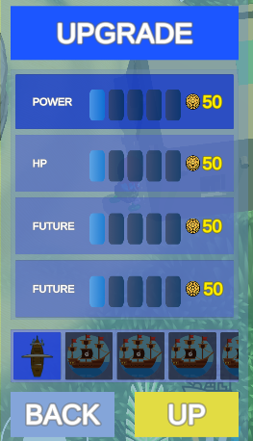

Dialogue UI

Once the player start a dialogue, the dialogue UI will show up, there is the name of who speak, and the dialogue plus the image of who speak, the setting of this is, unless the speaker says its name, the default name is ….

In this case, after the speaker says its name, it will appear as its name.

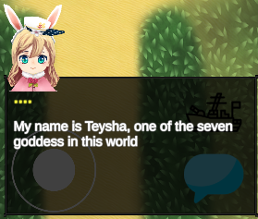

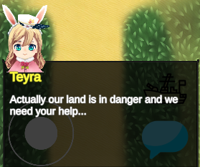There will also be multiple choice sections

And some loop for increase the entertainment, the dialogue will end once you get out the information needed. Since this interface is offline, the online one will be slightly different, it will give the player one more choice, to close the conversation because maybe the friend you invited is ahead on you and don’t want to resaw the conversation.

Enemy UI

When you are near an enemy the interact image will change and give you the possibility to interact with it.

This UI is composed by the title, the score which is measured by star a description and the choice to fight or not.

Map switch UI

In this UI

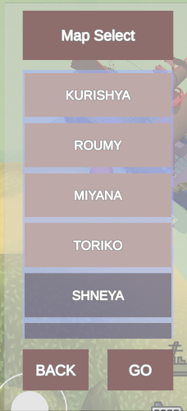Player can choose the map to switch.

**5.3.2 Rules**

**5.3.3 Scoring/winning conditions**

The winning conditions of the level is extremely easy, fight every wave until the boss appear, once you beat the boss you won the level.

**5.4 Modes and other features**

**5.5 Levels**

(Parte di mc)

**5.6 Flowchart**

|  |  |
| --- | --- |
| Achievement | Description |
| A smooth start with some prices…. | Charge one time |
| Power of money | Charge 3 times |
| It is easy with the power of cash | Charge 10 times |
| A perfect start | Clear a 3* in one level |
| Nobody is perfect, I’m nobody, so I’m perfect. | Clear a stage without losing hp |
| Such a lovely island | Select all dialogue options with Teysha |
| Such a bravery island | Select all dialogue options with goddess2 |
| Such a give me a break island | Select all dialogue options with goddess3 |
| Such a sad island | Select all dialogue options with goddess4 |
| Such a pain in the island | Select all dialogue options with goddess5 |
| Such a sleepy island | Select all dialogue options with goddess6 |
| Such a difficult island | Select all dialogue options with goddess7 |
| Is it worth to travel? | Select all dialogue with all goddesses |
| The first adventures | Clear the first level |
| The first-time being hero | Clear the first island |
| The first travel into another island | Travel once in another island |
| The first time to buy ship | Unlock 1 ship in shop |
| I’m just too rich or too active | Unlock every ship in shop |
| Do you need power traveler? | Upgrade once one ship |
| This is the max power | Upgrade every stat to max for 1 ship |
| Aren’t you over doing this? | Upgrade every stat of every ship to its max value |
| The start of the legend | Clear the story of the first island |
| The upcoming challenge | Clear the story of the second island |
| The chilling island | Clear the story of the third island |
| The sorrow island | Clear the story of the forth island |
| The painful island | Clear the story of the fifth island |
| Do you still need to be sleepy? | Clear the story of the sixth island |
| I’m the greatest pirates | Clear the story |
| Race through seven island | Obtain every achievement |
| Coming soon…. | …. |

**6. Game Characters**

**6.1. Characters design**

Thieves races is a RPG game, which includes a lot of NPC characters, but the playable characters is currently one.

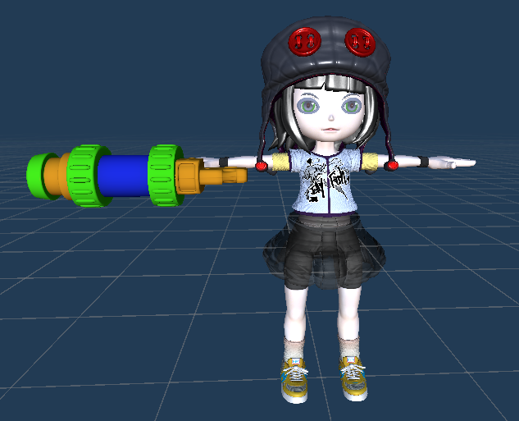

This is the controllable character, it is used for interact with map and system.

**….Parte di mc…. La tua barca….. con i stats…**

**6.2. Types**

The npc are, Goddesses and helper.

**6.2.1. PCs**

**6.2.2. NPCs**

6.2

The npc are, Goddesses and helper.

6.2.1 Goddesses

There is 7 goddesses one per island who need your help to free the island and its populated people from bad pirates.

Each one has a dialogue and in base on the situation, she can give you the goddesses bless which is a skill that can help you to overcome some obstacles.

|  |  |
| --- | --- |
|  | **Base information**  Name: Teysha  Location: first island  Personality: diligent  Description: Teysha is the oldest goddesses so probably that’s why she’s so diligent.  **Powers**  Name: Healthy field  Description: Teysha is named the goddesses of healthy, this skill can recovery any injury, even for ship.  Effect: recovery a % amount of ship health.  Cooldown: 20s. |
|  | **Base information**  Name: Teywa  Location: Second island  Personality: bravery  Description: Teywa is the tiniest goddesses, she’s audacious and most of the case doesn’t like to listen.  **Powers**  Name: Strength Will  Description: Teywa is named the goddesses of bravery, this skill can increase the will of people.  Effect: increase the damage of the ship.  Duration: 10s.  Cooldown: 20s. |
|  | **Base information**  Name: Teyfee  Location: Third island  Personality: Chill, calm.  Description: Teyfee’s the 2nd goddesses, she’s island is called the island for rest, probably because of her personality.  **Powers**  Name: Sacred rest and chill  Description: Teyfee is named the goddesses of chilling, this skill can calm down the people.  Effect: decrease the damage of enemy ship.  Duration: 10s.  Cooldown: 20s. |
|  | **Base information**  Name: Teyma  Location: forth island  Personality: sorrow  Description: Teyfee’s the 3rd goddesses, she’s island is called the island for rest, probably because of her personality.  **Powers**  Name: Sacred crying  Description: Teyfee is named the goddesses of chilling, this skill can calm down the people.  Effect: decrease the %hp of enemy.  Cooldown: 20s. |
| Coming soon… | **Coming soon…** |

6.3.1 citizens

People in the island who submitted to pirates.

6.3.2 Helper

People in the island who offer to help you in order to release the island. They give you some suggestion about some specific level.

6.4 Enemy

The enemy npc is used for starts a thieves races battle.

6.4.1 Enemy General

Actually they are the boss of the island, you need to defeat them, they got more hp and have more attack pattern then other normal enemy.

**7. Story**

**7.1. Synopsis**

A short recap

In an ancient era the world was populated by pirates, which were remarked as sea explorer with their extraordinary and resistent ship, they fought the sea with their strength and try to found treasure. A kid who admires them decided to became the greatest pirates of the world, so she starting to make the ship and started her first adventures, but unfortunately, she encountered a band of bad pirates who sink her ship and fall under water, just before she lost her conscious she heard a voices "Would you like to continue your dream?", when she open her eyes again, she was in an island and encountered a goddess, which told her that she was summoned by this goddess in this land named teyra a peaceful land which everyone could enjoy their life, but suddenly, out from nowhere, the army of darkness pirates appeared, they challenge people with "thieves races", a dangerous battle where who lose, lost everything. The goddess says that you were summoned because you have a strong will to complete your dream, with a bravery and kind heart, and asked you to free the island and her other sisters. In the meantime, the pirates army landed on this island, in front of the danger our main decided to help the goddesses, and started a fight with pirates, it was a tough fight but with Teyra blessing, you manage to defeat those pirates.

After that you asked what’s the current situation: Teyra have 7 island ruled by 7 goddess, every goddess possess a different kind of power, but they can't directly participate to the battle, all they can do is give some support, like the goddesses blessing, once every warrior on the island got defeated, the pirates win and can rule the island, actually they already conquered 6 island, so if they conquer this island, they can manipulate the land of teyra how they want, so again the goddesses pleased the traveler to help this land, The main character accepted to help the goddesses and started her story around Teyra.

She got through the seven island : Kurishya, Roumy, Miyana, Toriko, Shneya, Meisha, Kurishya, encountered the goddesses, fought the pirates kings army and their general.

After a long journey with surprise and danger, you finally manage to free the land from darkness pirates and also remembered as the greatest pirates in the Teyra land.

**7.2. Complete story**

7.2.1 Act1

You got summoned by the goddess in the island, who ask for your help, in the meantime where you asks what’s going on, the enemy pirates landed on the island and challenging you to a thieves races, a battle who lose, love everything, you accepted the challenge, but enemy was well prepared for the battle, they were more tough then what you expected, just when the battle seems to go in the bad way, the goddesses offered her bless to you, actually the goddesses posses the power of healthy, it can heal everything that exist in the land, even a ship, so with her help you managed to defeat the pirates, after that the goddesses explain the situation of this world, an darkness army of pirates appeared and conquered 6 island over 7, she asks you to help her to free the island and the goddesses, you accepted this quest and started your journey.

7.2.2 Act2

In the second island Roumy you encountered the 2nd goddesses, the most young one, Teywa, she’s a bravely goddesses, she want to free the people of the island as soon as possible, so she asked for your help, the general on the island is well known as very strong because of his defense ship is very hard that only other general can pierce down, but also, he got one weak spot or point, it was a caused by the previews attack on the island, the best warrior of roumy caused it, but after that he lost the battle. So you started to gather information about this weak spot, after you fought and captured some of the subordinate of the general, you managed to get out from them where the weak spot of the enemy general ship was, then with the help of the goddesses blessing which increase hugely the ship damage, you manage to defeat the general and free the island.

7.2.3 act3

In the third island Miyana you encountered Teyfee, the goddess which speak very slowly that could let you sleep directly. This island is doomed by the most aggressive general of pirates army, but however, Miyana is the island of chilling, this means, perfect place for break, there is beach, sea and everything else needed for a good rest, actually, because of this, maybe this island’s pirates are playing everyday at the beach, because the beach was populated by a lot of pirates, you hardly could tell which one was the general and to find it meanwhile taking the goddesses, let your guard down and started to play with pirates together.

At the end of the day, you remembered you came for free the island, so in the next day you started to find the General, but, with Teyfee’s calms voices, you let your guard down again and started to play with pirates again.

Then the third time, you didn’t bring goddesses with you and finally found the general, after challenging him with a thieves races, but the fight was very tough, because this general is the most aggressive one, he’s known as “The piercer” every single attack from him could be critical, in the middle of the battle, the goddesses gave you her blessing “Sacred rest and chill” which calmed down the head of pirates and decreases their aggressivity, with this you managed to defeat the pirates of the island, but Miyana was considered the best island for rest, the main stayed in the island 1 week more before left.

7.2.4 act 4

After landing on the Toriko island, considered as the land of sorrow, you see not only the people of the island were all in bad status, but actually, even the bad pirates looks pretty down, because the goddesses of the island’s bless is given to everyone, you encountered the goddess and you fought the general in this island, it was some kind of sad general, but u managed to free the island…

**7.3. Backstory**

The Teyra land is have the god authority which describe the rules of this entire world, in order to maintain these rules, every island have a goddess who protect the island the people who live on. So, to prevent the change of the rules of this world, only if seven goddesses agree, the world rules can be changed.

**7.4. Narrative devices**

The story is told mainly with talking with Npc and when enter the battle scene, once the player enters the battle scene, if there is a story directed in that battle scene, he will start the dialogue this also works when the boss appear they will start the dialogue.

**7.5. Subplots**

Once every island warrior lose the battle, the goddesses would be submitted to the pirates, this means that she can’t oppose to the will of pirates, so if the pirates successfully submit all goddesses they can change the world rules how they want.